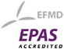
GRANDE ECOLE PROGRAMME

ESC PAU BUSINESS SCHOOL

FRENCH BUSINESS SCHOOLS & THE GRANDES ECOLES

- There are currently approximately 200 Business Schools in France with more than 100,000 students enrolled outside of the mainstream University system.

- Roughly 40% of these institutions are both State-recognised and provide qualifications accredited by the Ministry of Education.

- Of these, 32 schools are members of the prestigious Chapter of the Conférence des Grandes Ecoles (CGE) (http://www.cge.asso.fr/en/our-members/grandes-ecoles), including ESC Pau Business School (http://www.cge.asso.fr/en/our-members/grandes-ecoles/list-of-schools?page=17)

- Being a member of the CGE gives these schools a major competitive advantage over other categories of Business Schools as it confers the right to deliver fully accredited 5-year post Baccalaureate Masters Degrees (Bac+5) in the same way as State Universities.

- The Grandes Ecoles therefore operate a highly selective recruitment procedure.

- Added to their elite status, close ties with business and high graduate employment figures, this makes them attractive to the student market in spite of high tuition fees compared to the French Universities.

- The 32 Grande Ecole members of the CGE account for more than 50% of the total number of Bac+5 management graduates in France.

THE GRANDE ECOLE PROGRAMME (PGE)

- The Grande Ecole Programme is a three-year full time Master’s level programme recruiting candidates either onto year 1 or year 2, depending on their previous studies.

- The Grandes Ecoles generally recruit from 2 separate tracks of students after two years of higher education study.
- The first is the elite essentially publicly financed Preparatory School system taking in only the most academically able pupils from the French Secondary Education system, equivalent to 1.7% of all successful Baccalaureate candidates. These schools are specifically designed to feed into the first year programmes at Engineering or Business Grandes Ecoles and the Ecole Normale Supérieure. After 2 years of study pupils take a national written exam followed by an oral entrance exam at the institutions where they are eligible.

- The second recruitment track is open to Diploma level University students for PGE Year 1 or University Degree level graduates for PGE Year 2 intakes, who also take a (different) national entrance exam followed by an oral exam at the institutions where they are eligible.

- The possibility of recruiting students from both tracks is seen as positive within the Grande Ecole community, as expressed below in the official stance of the Conférence des Grandes Ecoles:
“These alternative enrolment tracks are highly prized by the Schools. It is a way for them to diversify the profiles of their pupils, to mix together a range of experiences and backgrounds, and therefore to enrich the group dynamics so useful for their teaching and learning strategy” (CGE, 2006).

- ESC Pau Business School’s Grande Ecole Programme aims to develop and educate globally responsible managers as future leaders for a fast-changing, complex and interconnected world. Our graduates are interculturally mobile and possess an entrepreneurial mind-set. They also readily understand the importance of making a positive contribution to Society for the global Common Good.

- Programme design takes this into account in the early stages of the programme by providing strong theoretical foundations in the Management Sciences and various opportunities for experiential learning within the school’s academic or associative structure, and in companies / communities nationally and internationally.

- As the students progress into years 2 and 3 they start to develop expertise in at least two domains of management and undertake a dissertation in a field of interest. The rationale behind this programme design is based on the original concept of the T-shaped manager (Hansen & Von Oetinger, 2001).

- ESC Pau Business School’s Grande Ecole Programme has been accredited by the EFMD (EPAS) since 2006.

- ESC Pau Business School’s Grande Ecole Programme includes strong collaboration with the region’s major industrial poles of excellence, including: Aeronautics (Turbomeca, Messier Bugatti Dowty), Geosciences (Total, TIGF), Food Industry (Euralis, Lindt & Sprüngli, Maïsadour), Carbon Fibre (Toray), Chemicals (SOBEGI, Arkema, Total Exploration), the Horse Industry (second largest training centre in France), and the Sports Industry (Quiksilver,Oxbow, Tribord-Décathlon, etc.).

- ESC Pau Business School offers as well a fully accredited 3-year post Baccalaureate Bachelor Degree (Bac+3)
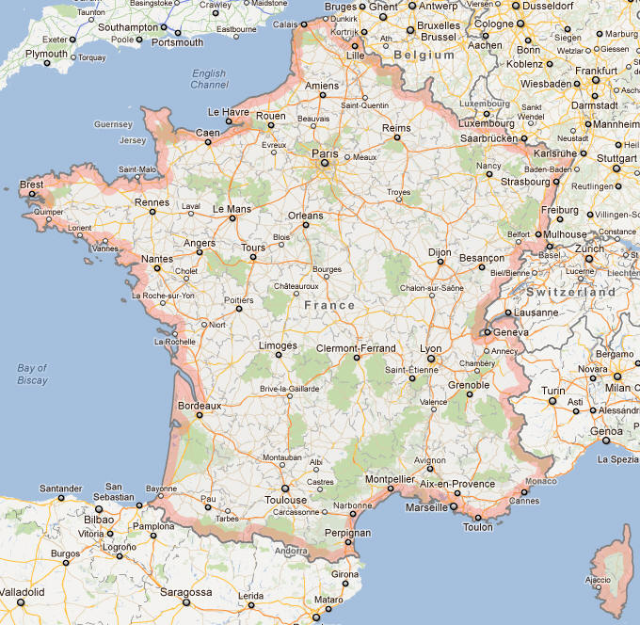

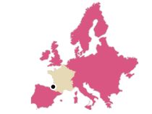

Bachelor Degree = 180 ECTS
ESC PAU BUSINESS SCHOOL
French Baccalauréat
PGE 1
PGE 3
PGE 2
High School
Bachelor 3

Preparatory classes or
Diploma Level University
(2 years)
Programme Grande Ecole (PGE)
120 ECTS
Masters Degree = 300 ECTS
180 ECTS
National Entry Exam
Bachelor 2
Bachelor 1
National Entry Exam
National Entry Exam

